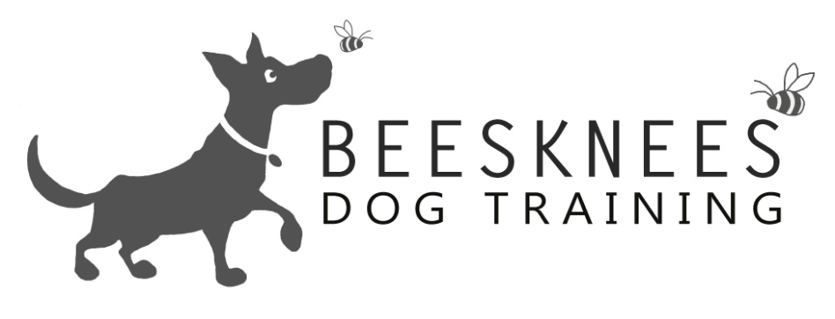

Welcome to the Basics Class
Welcome to Bees Knees Dog Training were I offer a variety of dog training options. All the training is Relationship Centred (putting your relationship with your dog at the centre of everything you do) I only use positive training methods focusing on having happy and polite dogs that enjoy training. Here is an overview of what I cover in the Basics Class. Any dog of any age can join the Basics Class as the classes are based on the dogs skill level. My classes are open to all dogs and breeds, also any humans that would like to come along too. I do a mix of obedience with tricks and information so that you get a well-rounded experience. Here is the Basics Class:
Obedience | Tricks | Information
Sit, realise and Down | Find | What is Relationship Based Training
Stand | Through Legs | Training tips
Leave: In front of you | Introduction to the Jump | Training excuse me
Leave: whilst moving | Targeting a cone | Dealing with jumping up
Loose lead walking | Spin | How to do out and off
Loose lead walking: Place | Back up | Remembering to praise a good dog
Loose Lead Walking: self control |  | Relaxation
Getting a heal with no lead |  | Please and a default sit
Recall |  | Why punishment doesn't work
Wait: in sit and down for 30seconds |  | What not to feed your dog
Wait: moving away and around |  | Dogs and children
Wait: for dinner
Drop and Gentle
Hand targeting
Watch me
Go to bed
Clicker Training
Anything that appears above that is also on the Puppy Class curriculum is an advancement of that skill. The Basics Class is a step up from the Puppy Class I would expect the dogs to have been introduced to some training.
The class runs for eight weeks at a cost of £74 (which works out to £9.25per session) You will get instruction, sheets to take home on each subjects, a certificate and rosette at the end of the course. So please come and check out dates and times at www.beeskneesdogtraining.co.uk. If you have any questions don't be afraid to contact me at: beeskneesdogtraining@gmail.com.

