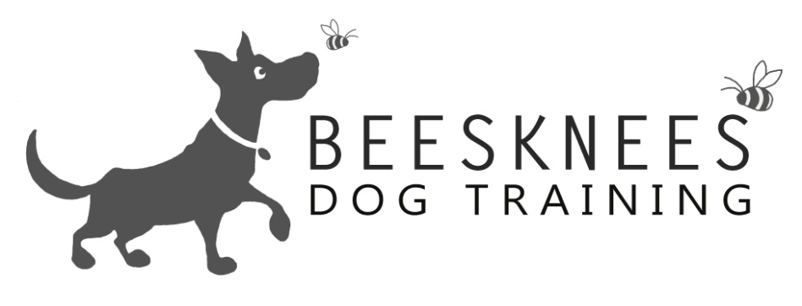

Welcome to The Intermediate Class
Welcome to Bees Knees Dog Training were I offer a variety of dog training options. All the training is Relationship Centred (putting your relationship with your dog at the centre of everything you do) I only use positive training methods focusing on having happy and polite dogs that enjoy training. Here is an overview of what I cover in the Intermediate Class. Any dog of any age can join the Intermediate Class as the classes are based on the dogs skill level. My classes are open to all dogs and breeds, also any humans that would like to come along too. I do a mix of obedience with tricks and information so that you get a well-rounded experience. Here is the Intermediate Class:
Obedience | Tricks | Information
Skills your dog should know: Sit and realise, down, stand, hand target, object target, watch, go to bed, please, clicker training | Skills your dog should know: Through legs, Back up, gate jump | What is relationship based training
Advancing: targeting an object | Advancing: The gate jump | Training tips
Advancing : go to bed | Introduction to: The long jump | Dogs and Toys
Introduction to the: Emergency stop | Introduction to: Jumping through a hoop | You control the play
Advancing: Recall | Introduction to: the Tunnel | Dog communication
Advancing: Wait | Advancing Through Legs to leg weave | Separation anxiety
Advancing: Leave | Advancing; back up from a distance. | Mental stimulation
Advancing: Loose Lead Walking | Introduction to: Roll over | Solving an unwanted behaviour
Advancing: Moving hand target | Introduction to: Crawling
Introduction to: distance training | Introduction to: Fetch
Introduction to: chaining behaviour

Anything that appears above that is also on our puppy or basic curriculum is an advancement of that skill. The Intermediate class is a step up from The Basic class I would expect the dogs to have good basic skills (please see our basic curriculum). If you are unsure which class your dog should be in then please get into contact and I can advise you.
Our classes run for eight Weeks at a cost of £74 (which works out at £9.25per session). You will get instruction, sheets on all the subjects covered, certificate and rosette at the end of the course. So please check me out at www.beeskneesdogtraining.co.uk for dates and time of all the classes. If you have any questions you have don't be afraid to contact me at: beeskneesdogtraining@gmail.com

