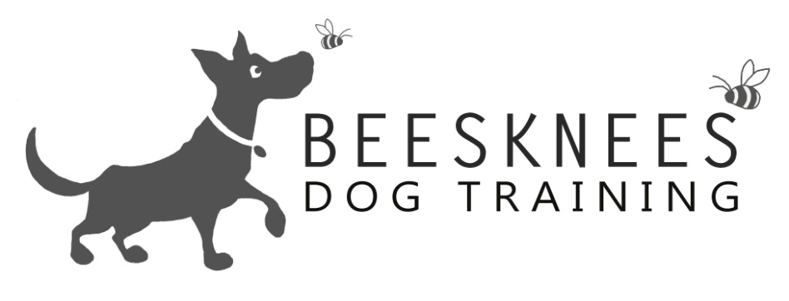

Welcome to the Puppy Class
Welcome to Bees Knees Dog Training were I offer a variety of dog training options. All the training is Relationship Centred (putting your relationship with your dog at the centre of everything you do) I only use positive training methods focusing on having happy and polite dogs that enjoy training. Here is an overview of what I cover in the Puppy Class. Any dog of any age can join the Puppy Class as the classes are based on the dogs skill level. My classes are open to all dogs and breeds, also any humans that would like to come along too. I do a mix of obedience with tricks and information so that you get a well-rounded experience. Here is the Puppy Class:

Obedience | Tricks | Information
Sit and realise | Find | What is relationship based training?
Please and a default behaviour | Through Legs | Training tips
Down |  | Crate training
Watch me |  | Keeping your dog healthy and well
Hand Targeting |  | Foods to avoid
Leave |  | Dealing with an unwanted behaviour
Loose Lead Walking |  | Puppy biting
Recall |  | Toilet training
Wait |  | Socialization
Clicker Training |  | Rude dogs and self control
Go say Hi |  | Our responsibilities
Examination and desensitization training |  | Stopping jumping up
The Puppy Class introduces dogs to training and is aimed for dogs at the very beginning of their training journey. The classes run for eight weeks at a cost of £74 (this works out at £9.25per session). You will get instruction, sheets to take home on each subjects, a certificate and rosette at the end of the course. Please check me out at www.beeskneesdogtraining.co.uk for dates and times of all the classes. For any queries that you may have don't be afraid to contact me at: beeskneesdogtraining@gmail.com.

